Cary, Jennie (based on CALM News 1997)
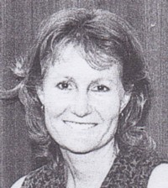
Commenced as research assistant at Dwellingup in late 1970s. Left Forests Department in early 1980s to travel in Europe. Joined Department of Conservation and Environment – Marine Branch in 1985. Seconded to senator Jo Valentine’s office for 1 year. Had 3 month contract to assist with environmental management strategy for Western Samoa. Joined Department of CALM Marine Conservation Branch at Fremantle, as marine ecologist in 1997. Senior Marine Ecologist in 2001. District Manager Walpole/Frankland 2012.

